Blueprint TicTacToe  
Version: 1.0.0

Inhoud

1. Intro 3

2. Functional design 4

2.1. Web UI 4

2.1.1. Game page 4

2.1.2. Game page 5

3. Technical design 5

3.1. Web API 5

# Intro

This document describes the functional aspect and realization of the TicTacToe program and the accompanying Web UI.

The TicTacToe projects goals are the following:

* Create an API that is able to hold the game state and use logic to change the game
* The API should be able to connect to different external engines to query for moves and score
* The front-end part has the ability to play the game in its entirety
* Using the front-end, the user is able to change settings like selecting different board sizes and players

The API will use ASP.NET framework using C#7.0.

The front-end will use React version 18 and fluent UI 9

# Functional design

This part will describe the functional part of the application, this is mainly focused on the front-end part of the code.

## Web UI

The web UI is the main way the user will interact with the application. It is divided into 2 main parts, the game page and the settings page.  
  
Each page will be discussed separately.

### Game page

**Visual design**

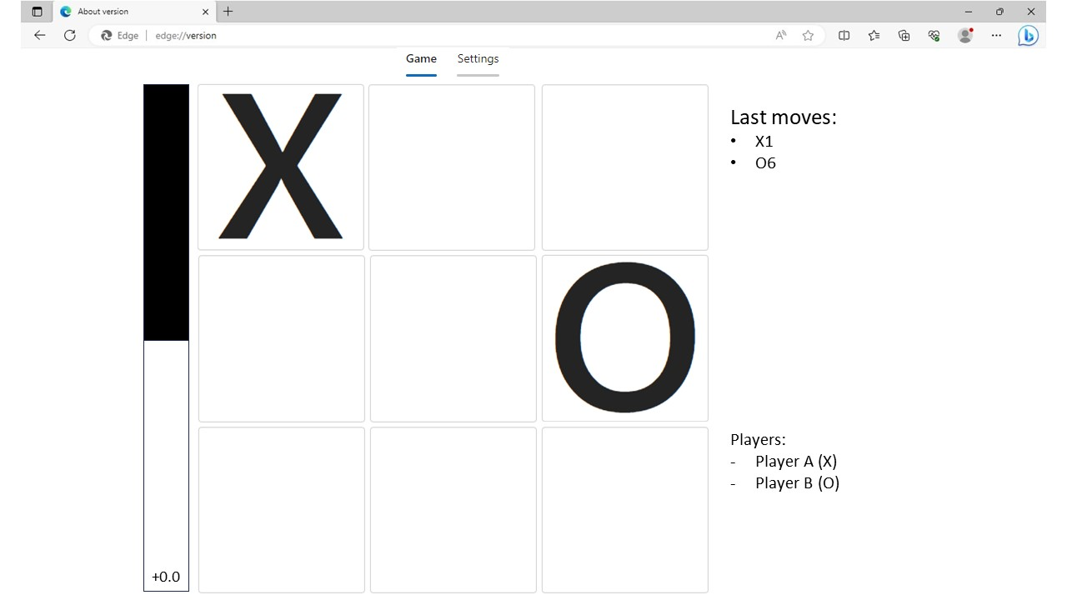

**Functional description**

This is the page where the user will actually play the game. The game is automatically started on load of this page. If the move is for an AI the game will automatically get the move from the AI and the game squares will be unable to be clicked.

On the right side of the game the user will be able to see a list of the previous moves. Below that an overview of the selected players will be seen as well as what symbol each player has.

The left side of the squares has bar that represents who has the current advantage in the game.

### Settings page

**Visual design**

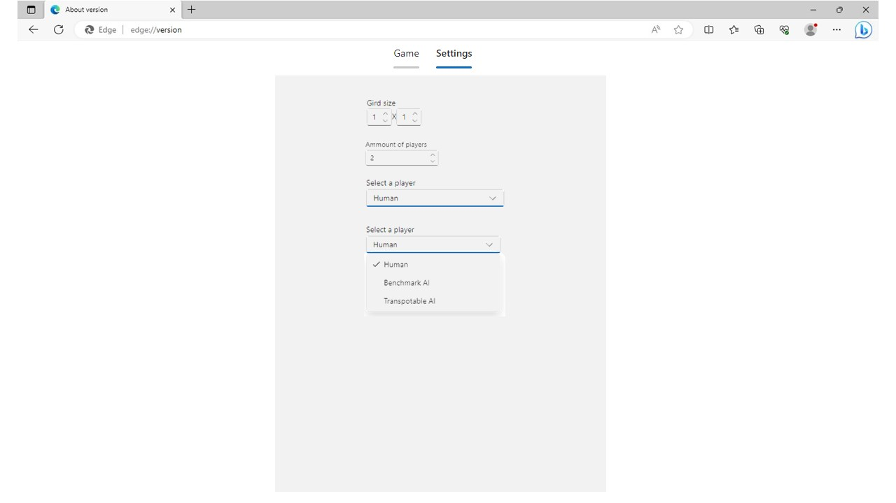

**Functional Description**

The purpose of this page is for the user to tweak the settings for the game. When the user returns the game page, everything will be reset and a new game will be started.

The following settings can be changed:

* Game board size X & Y
* Amount of players
* Type of player

Note on type of player, a dropdown will be available for each players. So the amount of players will equal the amount of dropdowns.

# Technical design

This part will cover the technical elements of the application and how they fit together.

## Web API

The web API does not use authentication, this means that the user can also play the game without using the UI.